Home Based Workstation Self-Assessment Checklist
This checklist should be used in conjunction with the EMHS Flexible Work Arrangements Policy. The checklist is designed for staff members seeking to work from home on a short or long term basis, to self-assess the comfort and suitability of their home based workstation.
The checklist identifies the optimal set-up for working at home that, where reasonably practicable, should be achieved, particularly if the staff member will be required to work from home for an extended period e.g. greater than two weeks. It is recognised that in some exceptional circumstances to maintain continuity of business, working from home is necessary for a limited duration and that the optimal set-up may not be achievable. Where a staff member indicates ‘No’ they should take reasonable care to prevent harm, e.g. taking regular breaks, stretching, sourcing appropriate equipment. Until you can access recommended equipment you may need to be ‘creative’. For example, using reams of paper to raise your monitor. Discuss possible solutions with your manager, Safety Rep or Work Health and Safety.
The staff member is responsible for providing home office equipment, including items associated with resolution of workstation problems. Refer to the ATO home office expenses website for information about home office expenses that maybe claimed when lodging a tax return. Salary packaging options can also be explored for purchasing portable electronic devices. Refer to the Salary Packaging information on the Hub.
Ideally workstations should be located away from thoroughfares and high-use areas of your home.

Instructions
- The staff member completes the checklist. Answering ‘No’ to any of the questions indicates a potential problem requiring action. Indicate in the ‘Comment’ field the actions that will be undertaken by the staff member to minimise harm.
- The staff member takes photographs of the home based workstation and chair. This should include a side on photo of the staff member seated at the workstation, and separate photos of the chair and desk.
- The staff member emails the completed checklist and photographs to RPGWorkHealthandSafety@health.wa.gov.au (for all EMHS, RPBG and AKG sites).
- EMHS Work Health and Safety reviews and adds comments and recommended actions (where applicable) and emails the signed form back to the employee.
- The employee sends the checklist to their manager.
- The manager reviews, adds any additional information, signs, and sends copies to the employee for their records.
- Repeat this assessment annually, or earlier if there are significant changes to the home based workstation (e.g. a house or office move).

Employee Details
Employee’s Name:
Manager’s Name:
Department:
Working from Home Location:
Specify Workspace within Location:
Date Checklist Completed:

Please list any reported pre-existing injury, illness, or symptoms that are currently being experienced or may be aggravated by work duties:

Checklist
Criteria | Yes | No | N/A | Comment(s)
Chair
The chair is comfortable, adjustable and supports your posture. | ☐ | ☐ | ☐
Is the backrest height adjusted so the back support fits neatly into the hollow of your back with approximately 2-3 finger width clearance between the front edge of the seat and the back of your knee? | ☐ | ☐ | ☐
Chair arms are not present or are low enough to clear the desk. | ☐ | ☐ | ☐
Is the seat adjusted high enough, so your arms/shoulders are in a comfortable position? i.e.  - Elbows slightly away from the body and slightly higher than your wrists.  - Elbows at 90 degrees aligned under the shoulders.  - Hips slightly higher than your knees.  - Thighs are not making contact with the under-surface of the desk.  - Feet flat on the floor or a footrest. | ☐ | ☐ | ☐
It is essential to have a suitable chair when operating a computer and it should possess the features depicted in this diagram.

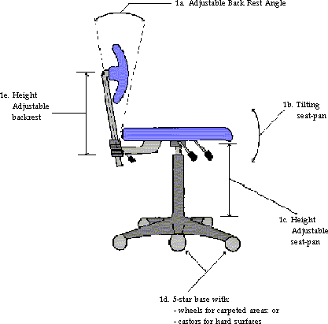

Desk
Can your desk accommodate all the equipment and materials needed for your job? | ☐ | ☐ | ☐
Is the desk deep enough so your screen can be positioned arm’s length away? | ☐ | ☐ | ☐
Is there sufficient space under the desk for your legs, knees and footrest? | ☐ | ☐ | ☐
Computer Monitor
Is the screen positioned so you can look straight ahead without twisting? | ☐ | ☐ | ☐
Is the top of the monitor at the same height as your eyes? If wearing multi-focal lenses, is it lower to avoid extending your neck / back? | ☐ | ☐ | ☐
If using a laptop computer:
- Is there a separate keyboard and mouse? | ☐ | ☐ | ☐
- Is there a laptop stand that raises the laptop screen to the same height as your eyes? Ideally also connect to an adjustable monitor. | ☐ | ☐ | ☐
Keyboard and Mouse
Is your keyboard positioned:
- Directly in front of you when you type? | ☐ | ☐ | ☐
- So your upper arms are close to your body? | ☐ | ☐ | ☐
- So your hands, wrist and arms are in a natural, straight position? | ☐ | ☐ | ☐
- So that your wrists are slightly extended (10-20 degrees) whilst typing, and not resting on the desk creating a sharp angle at the wrist joint? | ☐ | ☐ | ☐
Phone
If using a phone on a regular basis is this within reach? | ☐ | ☐ | ☐
If using the phone whilst typing or writing are head phones available? | ☐ | ☐ | ☐
Documents
If you frequently refer to papers and books, do you have a document holder or angle board? | ☐ | ☐ | ☐
Is the document holder positioned between the monitor and the keyboard or adjacent to it and at the same height as the screen? | ☐ | ☐ | ☐
Physical Environment
Are noise levels conducive to concentration? | ☐ | ☐ | ☐
Is the lighting adequate for the tasks that you perform? | ☐ | ☐ | ☐
Does your proposed working offsite location have residual current devices (RCDs) installed on the main switchboard? | ☐ | ☐ | ☐
Is the work related electrical equipment in good condition (e.g. without frayed or damaged leads)? | ☐ | ☐ | ☐
Will your field of vision be free from reflections (screen) and glare (lights and windows)? | ☐ | ☐ | ☐
Is the workplace clean, clutter free and well maintained? | ☐ | ☐ | ☐
Is the room and the electronic equipment sufficiently ventilated? | ☐ | ☐ | ☐
Can the temperature of the room be adjusted (i.e. is there air conditioning/ heaters? | ☐ | ☐ | ☐
Are there any slip, trip or fall hazards (e.g. floor coverings, mats, cords)? | ☐ | ☐ | ☐
Is a smoke alarm installed (preferably mains powered), regularly tested (monthly) and maintained (annual batter replacement)? | ☐ | ☐ | ☐
Are essential first aid resources available in the home? | ☐ | ☐ | ☐
Outcome
After following the above steps your posture and positioning should be similar to the diagram below. Remember to take a photo of your chair, a photo of your desk and a side on photograph of you seated at your workstation. Photos will be reviewed by EMHS Work Health and Safety.

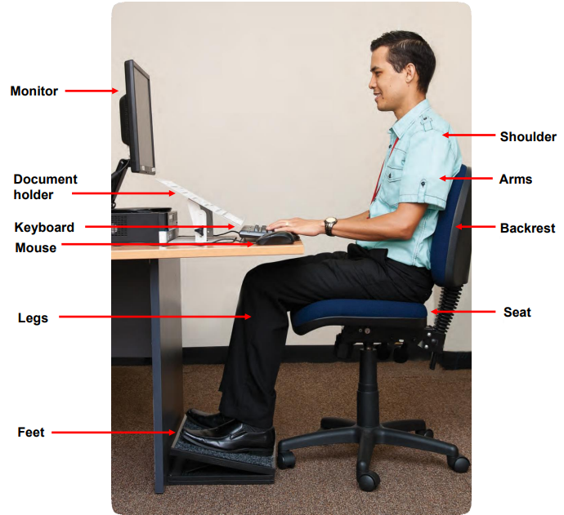

 | Yes | No | N/A | Comment(s)
I have been able to implement the above adjustments / work methods and am comfortable with my workstation set up and environment. | ☐ | ☐ | ☐

Summary of Problems (any ‘No’ answers)
Actions Taken to Resolve Problems
Recommended Further Action (to be discussed with the manager): to be completed by EMHS WHS
Employee Signature: |  | Date:
EMHS WHS:
Endorsed: | ☐ Yes ☐ No | Name:
Signature: |  | Date:
Comments:

Next annual risk assessment due
Manager Signature: |  | Date:
Comments:

