**Funding**:  Public  MVIT  W/Comp  NDIS  Other (specify): _____________

**ANCILLARY DEVICE FORM**

Please complete and email to: mailto: **FSH.Referrals@health.wa.gov.au**

|  |  |
| --- | --- |
| **Ward:** | **Doctor:** |
| **Diagnosis:** | |

**Truck Support Measurements** 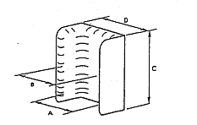

**A:** Hip Measurement____________ (in mm)

(straight line across the trochanters with legs in neutral)

**B:** Waist Measurement________ (in mm)

(straight line across narrowest point of the waist)

**C:** Height Measurement_________ (in mm)

(from top of seat cushion to the axilla, -25mm)

**D:** Wheelchair Width_______ (in mm)

(required width of wheelchair or current wheelchair width)

slung backrest upholstery

board backrest

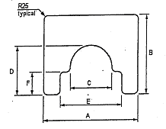**Tray Measurements**

**A:** ______ Width of tray (width of wheelchair seat +200mm)

**B:** ______ Depth of tray (usually 550mmm can be customised)

**C:** ______ (width of trunk at armrest height +30mm)

**D:** ______ (backrest of wheelchair to front of trunk)

*E+F are only needed if foam lateral trunk support cushion is being used or is required*

**E:** ______ Width of wheelchair

**F:** ______ Relief for foam lateral trunk support cushion ( 14cm)

|  |  |  |
| --- | --- | --- |
| Controller cut out | Left Side | Right Side |

**Standard Tray Options** (padded with Velcro straps)

630X550mm = (43cm wide wheelchair) ◻

660X550mm = (46cm wide wheelchair) ◻

690X550mm = (49cm wide wheelchair) ◻

**Customized Tray Options**

Clear tray with straps ◻ slide in double mounting brackets ◻ flip over left ◻ right ◻

|  |  |  |  |
| --- | --- | --- | --- |
| Therapist Signature : | | Print Name: | |
| Therapist HE number | | Phone/Pager: | |
| **REC STAFF ONLY** | Date: | Cushion Number: |  |
| Referral Number: | | Technician: |  |

Terminology complies with ISO 7176-26.